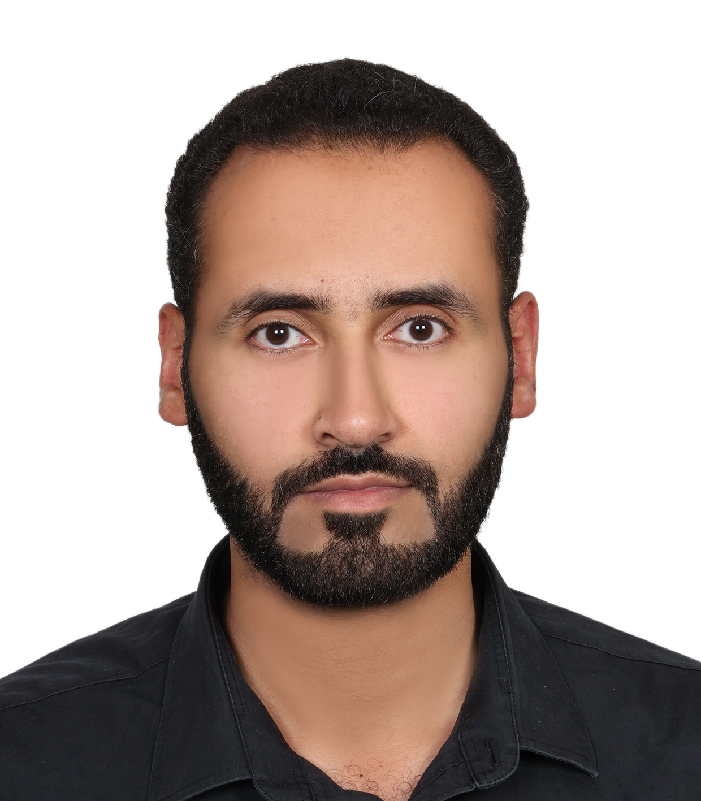

**Mohamed Ahmed Hashim Mohamed**

**Abu Dhabi – AL Ain | U.A.E |**

**Nationality: Sudanese**

**Mobile: 00971563300750**

**Email : mody.hashimm@yahoo.com**

**Objective**

Seeking a position of, Administrative Assistant and customer service Supervisior within local or international organization where I can transform my learning into practical experience, in order to support it and help it develop and grow in Administrative Assistant, customer service careers.

Am currently working as customer service consultant in private sector related to Judicial department.

**Position applied**

Administration Assistant

IT support Engineer

Customer service supervisor

Jr. Assistant producer

**Area of Experience**

IT Support Engineer

Administration Assistant

Customer service

Jr.Assistant producer

**Education**

**University:** ALHOSN University - Abu Dhabi

**Degree:** Bachelor of Science in Software Engineering (BSSE), 2014

**Professional and technical Courses achieved:**

* Java Programming & Data structure
* Database Management System
* Web development and design
* Computer Architecture and Organization
* Software Requirement and Analysis
* Software Quality and Testing
* Distributed system
* Computer network
* Operating System
* **Work Experience**

**Customer Service Consultant, at Infinity International Legal Consulting.**

**Abu Dhabi - UAE**

22/05/2021 – Present

* Open cases such as civil claim, commercial claim, payment claim, family claim, urgent claim and employment claim.
* listening to the customers and understanding them for the case and consulting the customer rated to the cases.
* Consulting the customer and explaining for the customer issue.
* Open cases execution, an appeal and an exception for EID and resident visa.
* Identify and asses customer’s needs to achieve satisfaction.
* Handle customer complaints, provide appropriate solutions and alternatives within the time limits follow up to ensure resolution
* Follow communication procedures, guidelines and policies.

**Administrative Assistant For Development and Performance Improvement Affairs , AL Rahman Center For Special Care**

**Omdurman – Sudan**

Full time ( on site ), 05/05/2022 – 05/07/2022

Full time ( remotely ), 10/07/2022 – 15/04/2023

* Provides support and assistance staff and students
* Answers phones, assists students and staff, greets and directs visitors, takes messages and provides information.
* Completes Daily Review of Absences in the Mornings, Assists staff with attendance system and completes a monthly activity report.
* Oversees and implements a board range of office operations.
* Collects data and prepares numerous monthly and yearly reports including student enrollment , teacher absent report, staff absent report and quarter- end and year- end government reports.
* Records student attendance, updates computer records and prints out.
* Maintains and files all confidential student records and cumulative folders.
* Maintains and updates the student and transfers students into and out if the Center records.
* Assists with the maintenance and updating of class lists.
* Prepares and distributes transcript requests.
* Completes audits ensure the accuracy of all information entered in the center database. Runs various reports from the database as requested by the Manager.
* Provide assistance and guidance to students, staff, parents and the public. Answer phones and directs visitors.
* Records and updates student medical information. Cares for sick/injured students and contacts parents. Supervises the activities of students in the office.
* Assists in planning and preparation for parent/teacher interviews under the Manager.
* Assists in the preparation of report cards under the manager.
* Carries out office equipment maintenance procedures.
* Maintains and updates inventory of Center and office equipment and furniture.
* Prepares requisition for signature.
* Provides assistance in the preparation of student timetable under the manager.
* Receive and sends electronic communication.
* Opens and distribute mails.
* Monitors budget and forecasts budgetary needs, Maintains computerized financial records for Center operation budget, processes statements, reviews monthly budget control statements. Updates staff and teachers regarding expenditures and balances. Liaises with Finance regarding budget Center.
* Prepares requisitions for materials and supplies. Checks and distributes materials as received.
* Preforms budget tracking tasks.
* Promotes a welcoming, caring, respectful and safe work environment.
* Maintains efficient relationships with Center Staff to support students
* Assists team members during peak periods, including coverage for staff absences.
* Proven public relations skills and demonstrated ability in promoting and maintain effective working relations with public, student , co-workers, Center staff and Management.
* Understanding and efficiently utilizes the technologies used by the school.
* Coordinate and supervise Management.
* Provides leadership and coaching to other staff as required.
* Reports and merits and concerns related to office staff performance when required.
* Assists with training new staff. Offers suggestions to manager
* Organizes ,prioritizes and complete all task by assigned deadlines.
* Provides timely responses to requests by AL Rahman center for special care staff, students and agencies.

**IT Support and retail projects, Chalhoub Group**

**Abu Dhabi - UAE**

Part time, 12/02/2017 – 22/11/2020

* Working as part time retails only

Full time, 04/01/2015 – 12/02/2017

• Troubleshooting IT issue (Systems and Networks) in Abu Dhabi, AL AIN and Tryano.  
• Working as IT assistant project member for some projects in Abu Dhabi and AL Ain for new store, renovation, relocation and closing of stores.  
• Working as IT support retail shops for all IT related issues  
• Configuration and troublshooting POS (Point of Sale) machines.  
• Working on Symantec backup exec for all weekly and monthly backup for Abu Dhabi office Server.  
• On field support for all retails outlets in Abu Dhabi, Tryano and Al-Ain.  
• Using Dude remote Management for monitoring and fixing the PC and POS.

• Configuring and troubleshooting of Email clients like Outlook, Network\Standalone printers, shared drives and business related applications as per company standard.

* Configuring the emails using built in application for all kind of smart phones like Apple and Samsung.
* Installing, Configuring, Troubleshooting and updating patches for Kaspersky antivirus software in Client machines.
* Responsible for Facility Management and Vendor Management in Corporate Sites.
* To maintain records of all equipment's regarding their specifications, location, warranty/maintenance, history availability and utility.
* Set up workstations and laptops for new employees, configured systems, ensured network connectivity, and installed and tested hardware and software and train new employees.
* Assisted in troubleshooting user problems relating to Operating System issues (Windows XP and Windows 7 and windows 8), Network Connectivity, TCP/IP configuration, upgrades, MS Office products and Internet connectivity.

**IT Service Support ( internship ), Arabtec Construction**

**Abu Dhabi - UAE**

09/03/2014 - 01/05/2014

* IT Helpdesk Phone operator.
* PCs-Laptops Installation Setup.
* Installed and maintain a variety of third party applications within Arabtec PCs Environment
* Work on server 2012 for managing users credentials such as Reset users passwords.
* Have experience in Network Infrastructure Cabling such as Activate-Deactivate the network ports through the IDF ( Intermediate distribution frame)
* Support IT help desk for manage/assign/resolve all related indicated from the users.

**Assistant producer, Freelancer,**

**Abu Dhabi - UAE**

Feb/2009 - Jan/2015

* Organization
* Time management
* Facilitated Meetings
* Made sure Production matters were attended to in place of the Producer
* Worked as part time for 6 days in AD TV in the show called The truth of journey (رحلة البحث عن الحقيقة)
* Worked as part time in AD TV

**Skills**

* Office 2003/2007/2010/OFFICE365
* Windows OS 95/98/ME/2000/XP/VISTA/WINDOWS 7/WIN8/WIN10
* Mac OS (Leopard/ Lion X).
* Familiar with Programming Language (Java, VB).
* Familiar with HTML, CSS and web development/web designing (Visual Studio 2012).
* Familiar with SQL (Microsoft SQL Server Management Studio).
* Familiar with Software Development Life Cycle.
* Install, test, trouble shoots and maintains hardware and software.
* Respond to request for technical assistant by phone and face to face.
* General knowledge in the active directory.
* Fundamental of cloud computing.
* Fundamental of computer security.
* Fundamental of recovering system and disaster recovering.
* Assign IP Address
* Format of IP Address
* Subnet IP Address
* Team work
* Team player
* Strong customer service
* Decision making
* Solving problems
* Lead management
* Team motivation
* Team spirit

**Courses Attended**

* Cloud Computing.
* Microsoft offices 2010
* CompTIA A+ 1000 **( Alison online course )**
* Fundamental of Computer Network **(Udemy certificate )**
* Fundamental of Computer Network Security **(Udemy certificate )**
* Digital Marketing Certification: Master Digital Marketing **(Udemy certificate )**
* IP Addressing And Subnetting **(Udemy certificate )**
* Public speaking skills **(Udemy certificate )**
* Communication within team **(Linkedin certificate )**
* Certified customer service specialist **(Udemy certificate )**
* Positive psychology **(Udemy certificate )**

**Languages**

* Arabic: Fluent (Mother Language)
* English: Great
* Japanese: Basic
* German : Basic

**hobbies and interests**

* Travelling.
* Reading.
* Tennis.
* Jazz and classic music.
* Solving problems.
* GYM
* Nutrition

**Personal information**

**Name: Mohamed Ahmed Hashim Mohamed**

**Age: 35**

**Material status : Married**

**Visa Status: Valid till 31/07/2025**

**Driving license available**

**My LinkedIn page :** <https://www.linkedin.com/in/mohamed-ahmed-hashim-5ab38a11a/>